**Experiment No :** 23

**Experiment name :** Write a program in C to count the total number of vowels or consonants in a string

**Methodology :**

In this program, we first declare an array inputString to store the user's input string. We also initialize two variables vowels and consonants to count the number of vowels and consonants in the string, respectively.

**Flow-Chart :**

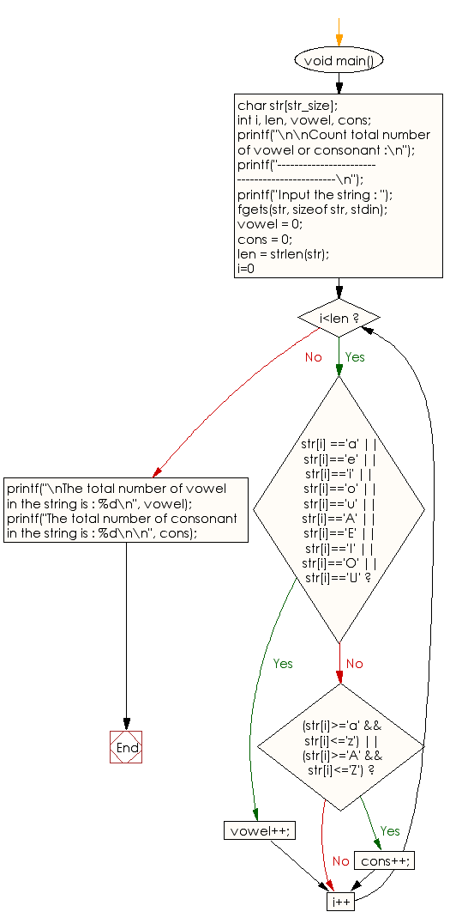

**Code :**

#include<stdio.h>

#include<string.h>

#include<stdlib.h>

#define strSize 1000 //declear the maximu size of string .

void main()

{

char str[strSize]

int i , len , vowel , cons ;

printf("\n\nCount total number of vowel or consonet. \n");

printf("----------------------------------------------\n");

printf("Input the strin : ");

fgets(str, sizeof str , stdin)

vowel = 0 ;

cons = 0 ;

len = strlen(str);

for(i=0 ; i<len ; i++){

if(str[i] == 'a' || str[i] == 'e' || str[i] == 'i' || str[i] == 'o' || str[i] == 'u' ){

vowel++ ;

}

else if(str[i] == 'A' || str[i] == 'E' || str[i] == 'I' || str[i] == 'O' || str[i] == 'U' ){

vowel++ ;

}

else if((str[i]>='a' && str[i]<='z') || (str[i]>='A' && str[i]<='Z')){

cons++ ;

}

}

printf("\nTotal number of vowel in the string is : %d\n",vowel);

printf("\nTotal number of consonant in the string is : %d\n",cons);

}

**Output:**

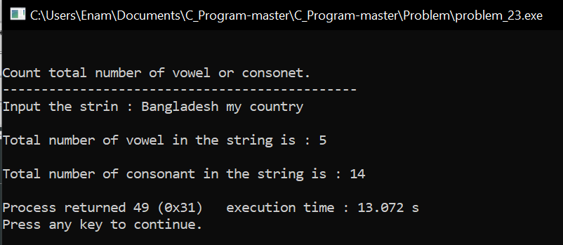

**Result discussion :**

1. We use fgets to read the input string from the user, including spaces, and store it in the inputString array.
2. Then, we use a for loop to iterate through each character of the input string. Inside the loop, we convert each character to uppercase using the toupper function from the <ctype.h> header. This step is essential to handle both uppercase and lowercase vowels and consonants.
3. We check if the character is an alphabet (A-Z) using the if condition. If it is an alphabet, we further check if it is a vowel (A, E, I, O, U) and update the respective counters accordingly.
4. Finally, we print the counts of vowels and consonants in the input string.